Storm Malik public briefing

Issue Date: Friday, January 28,2022

With the Met Office upgrading its weather warning of strong winds to Amber, we are encouraging residents and businesses to be prepared for the worsening conditions which we can expect from around 7am-3pm tomorrow (Sat, Jan 29).

Can we please ask as a matter of urgency that you share this briefing through any means at your disposal or channels you may have – be that digital, through word of mouth/printed copies etc – to make our communities as prepared as possible.

An Aberdeenshire Council IMT met today to review the council teams’ readiness and will meet throughout the weekend to review and ensure services are deployed as required.

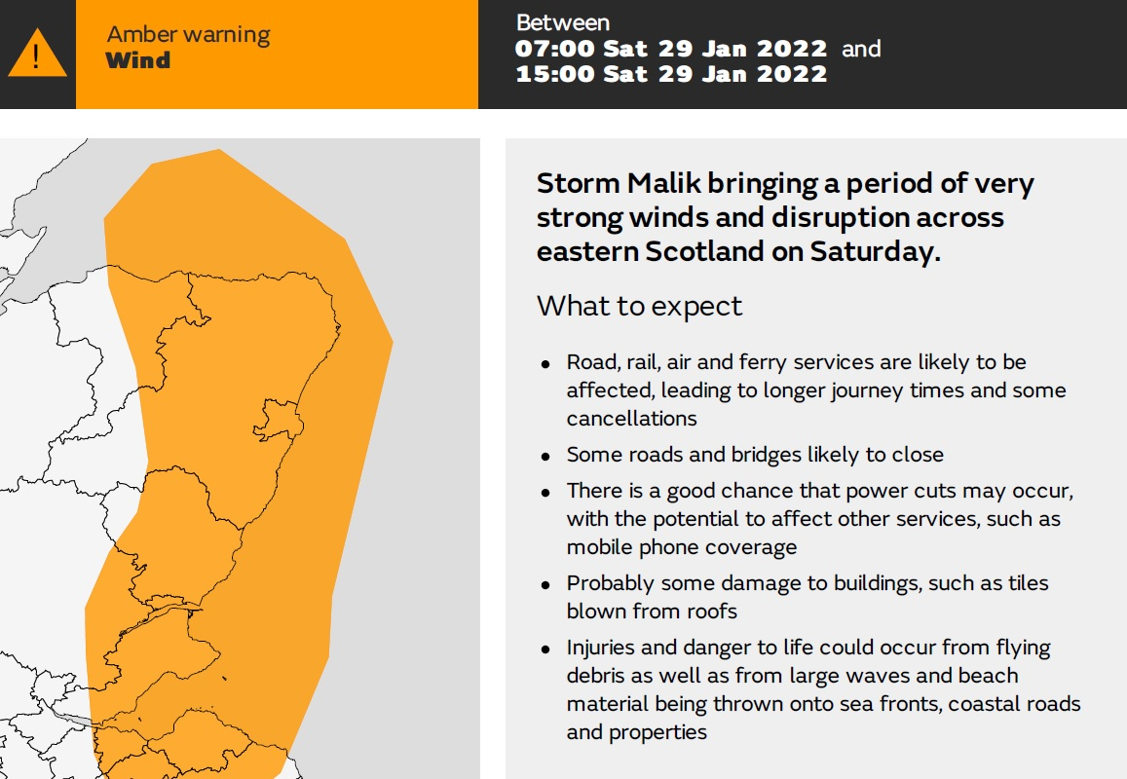

An area of very strong west or northwest winds will cross Scotland on Saturday morning in association with Storm Malik before easing during the afternoon.

The strongest winds are expected in the east of Scotland later in the morning with gusts of widely 50-60mph likely with a short period of gusts in excess of 75 mph, particularly for Moray, north Aberdeenshire as well as the Lothians.

These winds have the potential to cause power cuts, loss of mobile phone signal, damage to buildings, injury to persons, fallen trees and travel disruption.

Some communities may experience coastal surge and we are readying stock of sandbags at our depots: https://www.aberdeenshire.gov.uk/environment/flooding/sand-bags/

ReadyScotland have lots of great advice on being prepared for the high winds here: https://ready.scot/respond/severe-weather/storms-and-winds

But essentially, before the high winds arrive you should:

- Secure loose objects such as ladders, garden furniture or anything else that could be blown into windows or cause danger;
- Stock up on batteries for torches, bottled water and food supplies in the event of power outages;
- Check on vulnerable neighbours or relatives, share this messaging with them and help them prepare;
- Keeping checking the weather forecast and keep up-to-date with the latest weather warnings at https://www.metoffice.gov.uk/

This briefing is also being shared with all local press outlets including newspapers and the broadcast media, together with local radio stations including:

Northsound Radio, Original FM, Waves Radio,
Buchan FM and Deveron FM

Ends

